Ideation Phase
Empathize & Discover

Date | 15-7-2026
Team ID
Project Name | Book Store
Maximum Marks

Empathy Map Canvas – Theory (BOOKSTORE Project) : An Empathy Map Canvas is a design thinking tool used to understand the needs, thoughts, feelings, behaviors, and challenges of customers. It helps developers view the product from the customer's perspective, allowing them to design solutions that solve real problems. By understanding what users say, think, do, and feel, the development team can create a better user experience and improve customer satisfaction.
In the BOOKSTORE project, the primary users include students, teachers, professionals, book readers, and book sellers. Customers want a simple and reliable platform where they can search for books, compare prices, read reviews, place orders, and track deliveries without difficulty. They expect a secure, fast, and user-friendly online shopping experience.
Customers often think about whether the required book is available, whether the price is affordable, and whether the website is trustworthy. They also want quick delivery and secure payment options. However, they face several challenges, such as limited availability of books in physical stores, time-consuming searches, confusing website navigation, and delayed deliveries. These problems can make customers feel frustrated, disappointed, and dissatisfied.
The empathy map also considers the customer's actions. Users usually search for books, compare different options, check ratings and reviews, and make purchase decisions based on price, availability, and delivery time. They are influenced by recommendations from friends, teachers, social media, and customer reviews before making a purchase.
The proposed BOOKSTORE application addresses these customer needs by providing an easy-to-use web platform developed using the MERN Stack (MongoDB, Express.js, React.js, and Node.js). The system offers advanced book search, category-based browsing, secure user authentication, shopping cart functionality, online payment support, order tracking, seller management, and personalized book recommendations. These features help customers save time, make informed decisions, and enjoy a smooth online shopping experience.
Example:
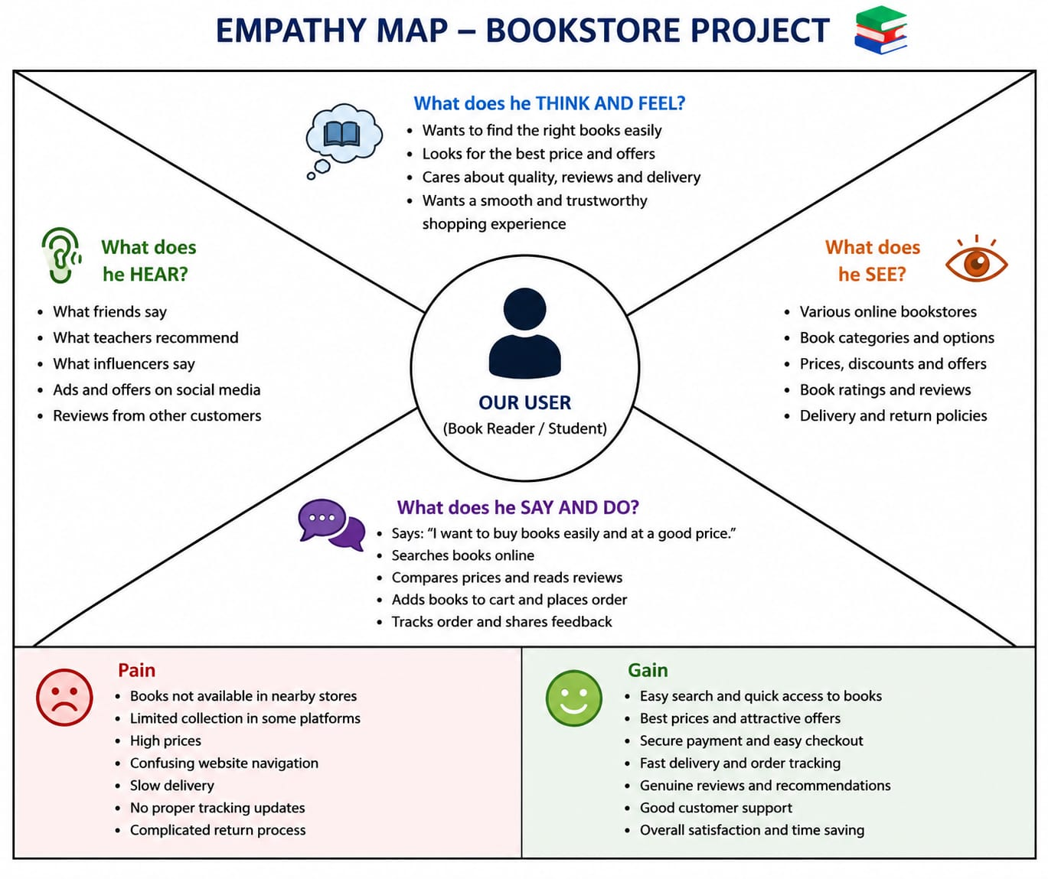

Reference: C:\Users\spras\OneDrive\Pictures\b0b6c71f-885a-4cc7-8244-a92f0b999de3.png

Example: Online Book Store Application
